Truncated Icosahedron Definition
# Source: AI Source: Provided by: [Data Path: Persons Table -> ID Column: 1, Name_En Column: Motasem Essam] -> From: [ChatGPT] on [7/25/2026]
A Truncated Icosahedron is a three-dimensional polyhedron formed by cutting off the twelve vertices of an original icosahedron using planes.
The truncation process creates twelve new pentagonal faces while modifying the original twenty triangular faces into hexagonal faces.
A uniformly truncated icosahedron is an Archimedean solid.

Geometric Structure
# Source: AI Source: Provided by: [Data Path: Persons Table -> ID Column: 1, Name_En Column: Motasem Essam] -> From: [ChatGPT] on [7/25/2026]
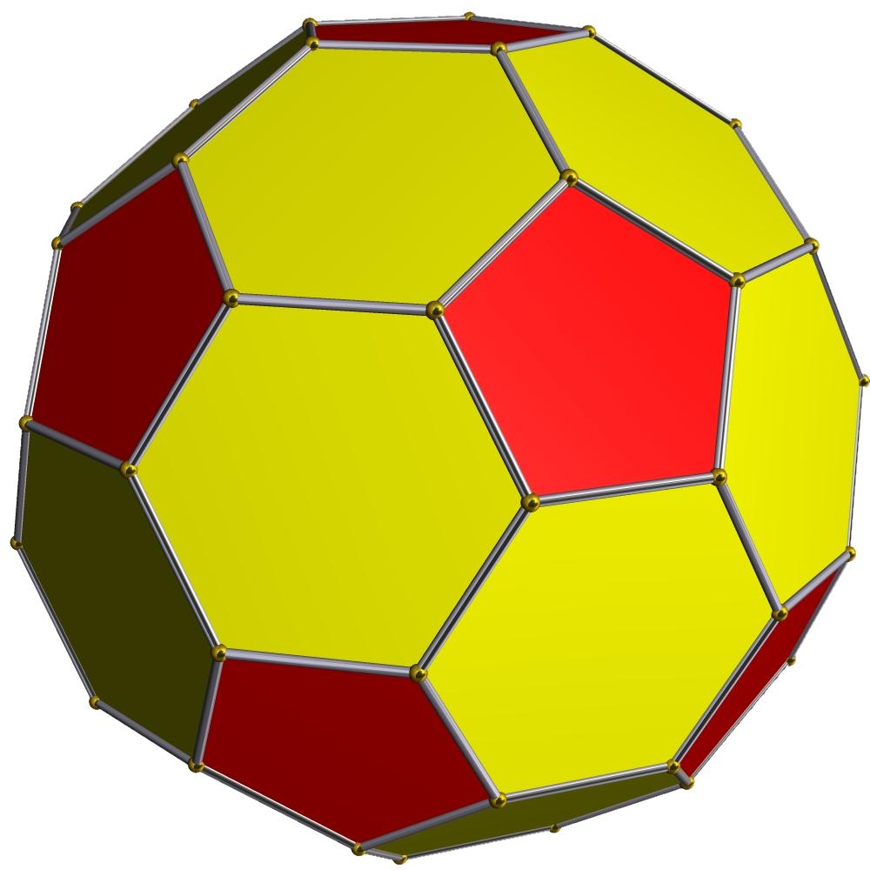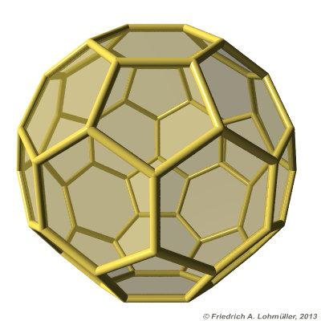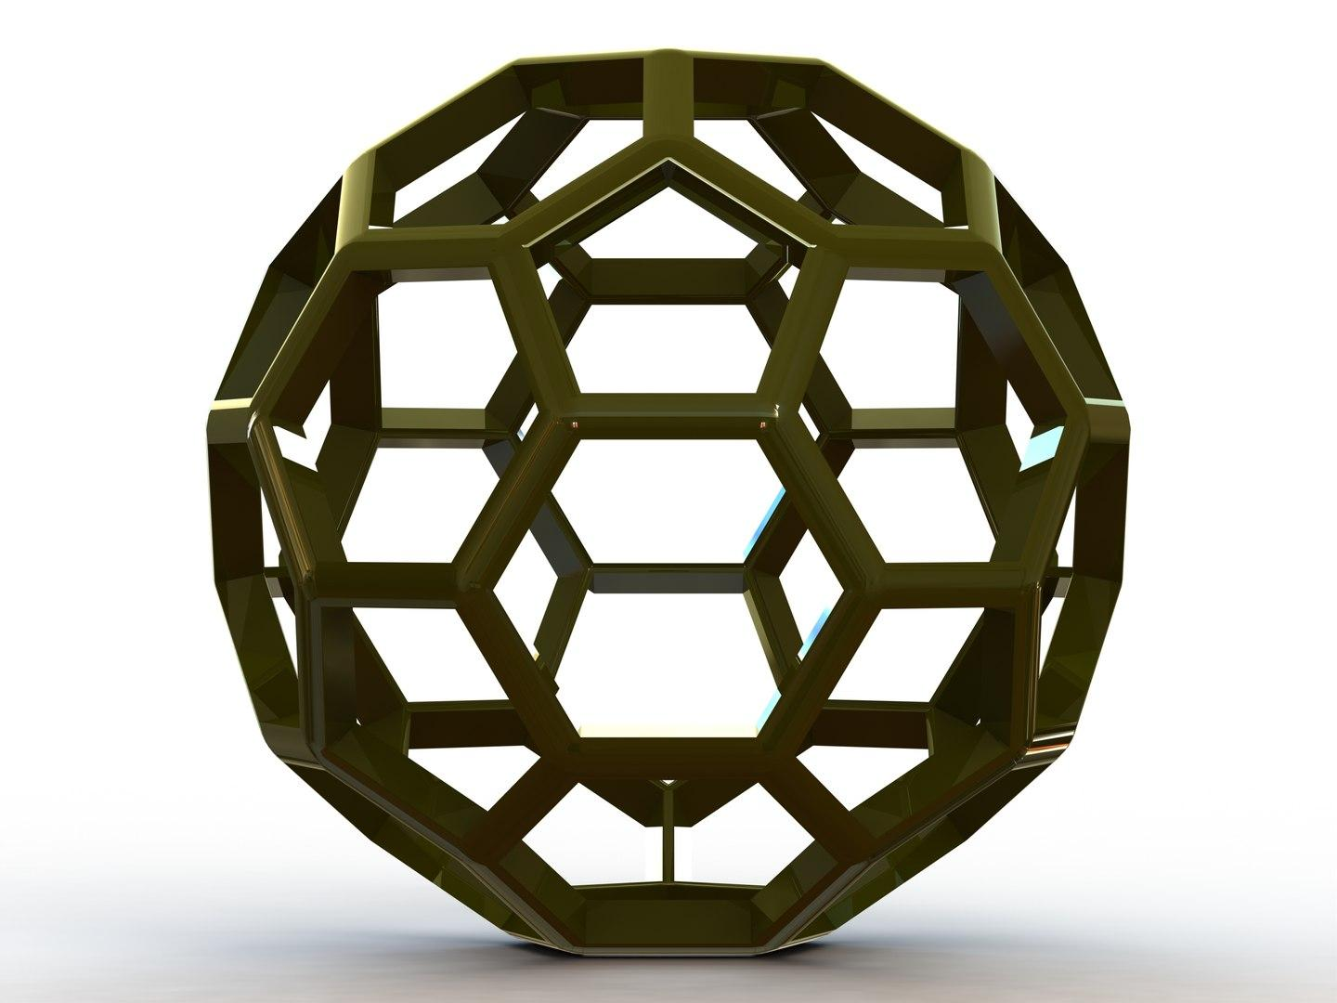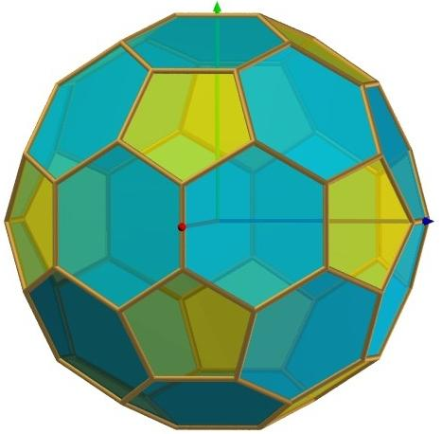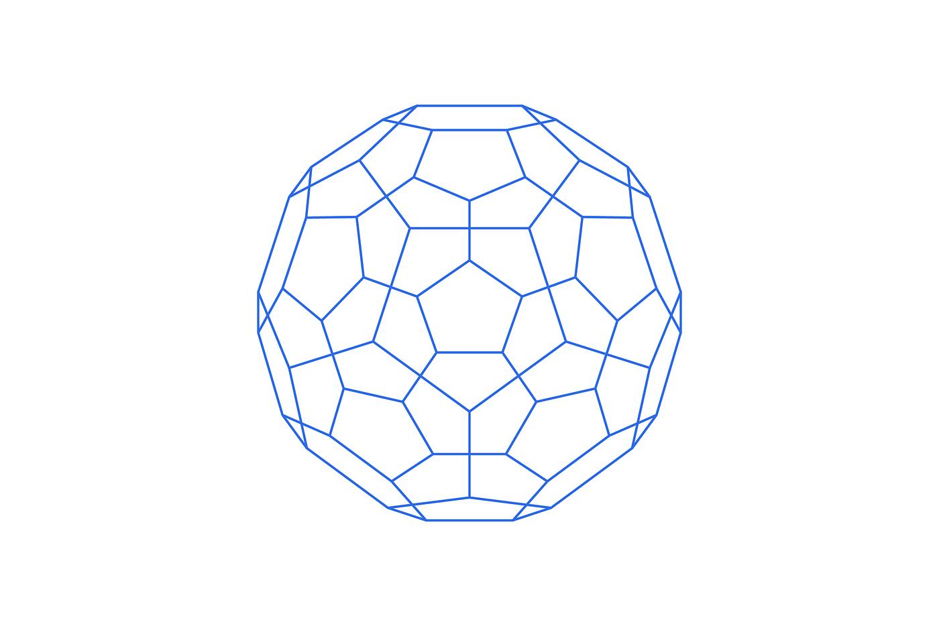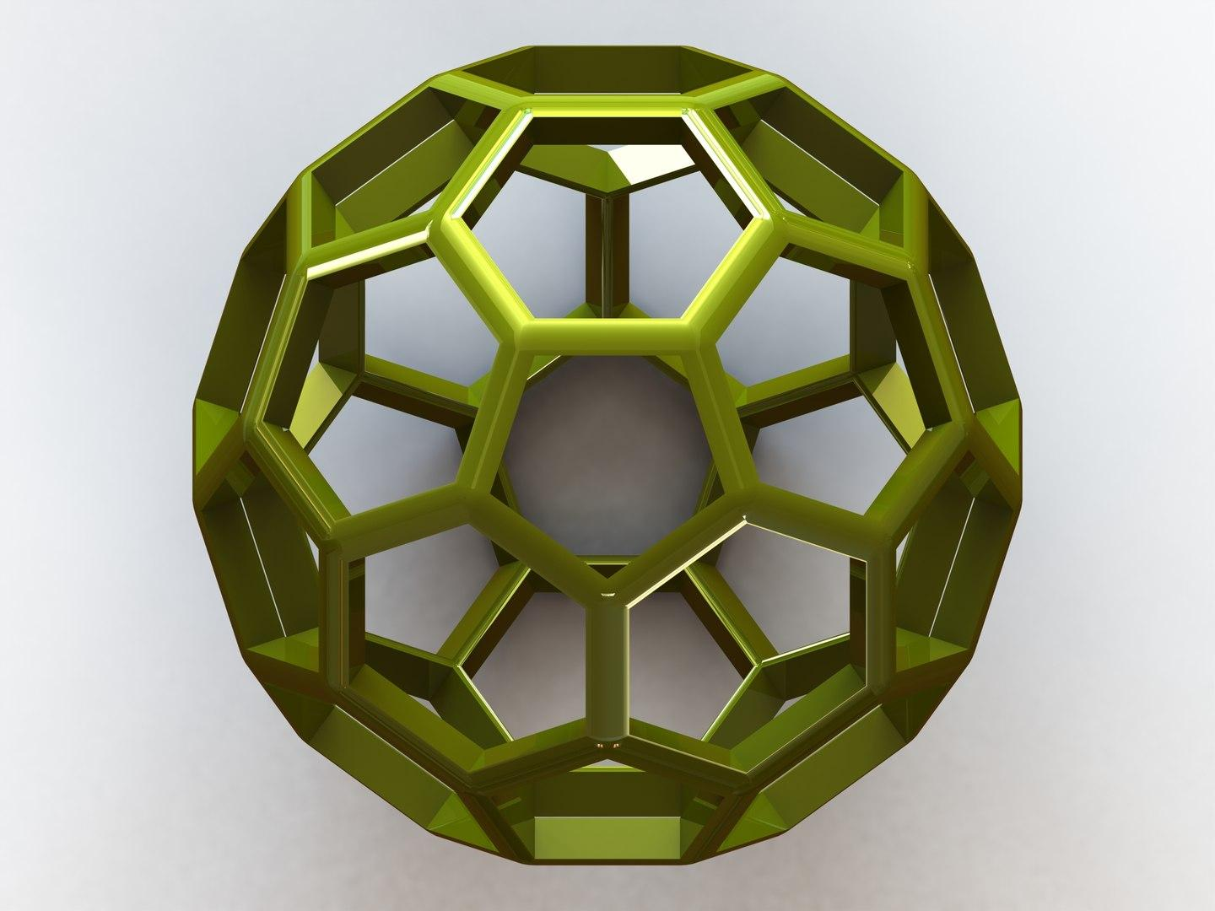
A truncated icosahedron consists of:
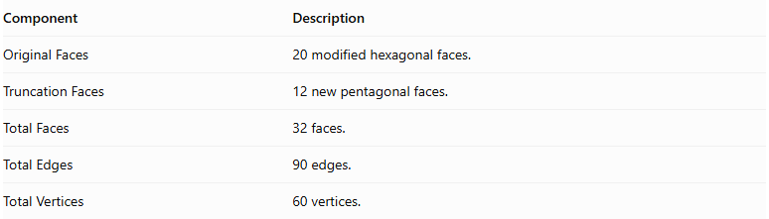
Component | Description
Original Faces | 20 modified hexagonal faces.
Truncation Faces | 12 new pentagonal faces.
Total Faces | 32 faces.
Total Edges | 90 edges.
Total Vertices | 60 vertices.

Face Composition
# Source: AI Source: Provided by: [Data Path: Persons Table -> ID Column: 1, Name_En Column: Motasem Essam] -> From: [ChatGPT] on [7/25/2026]
The truncated icosahedron contains two types of polygonal faces:
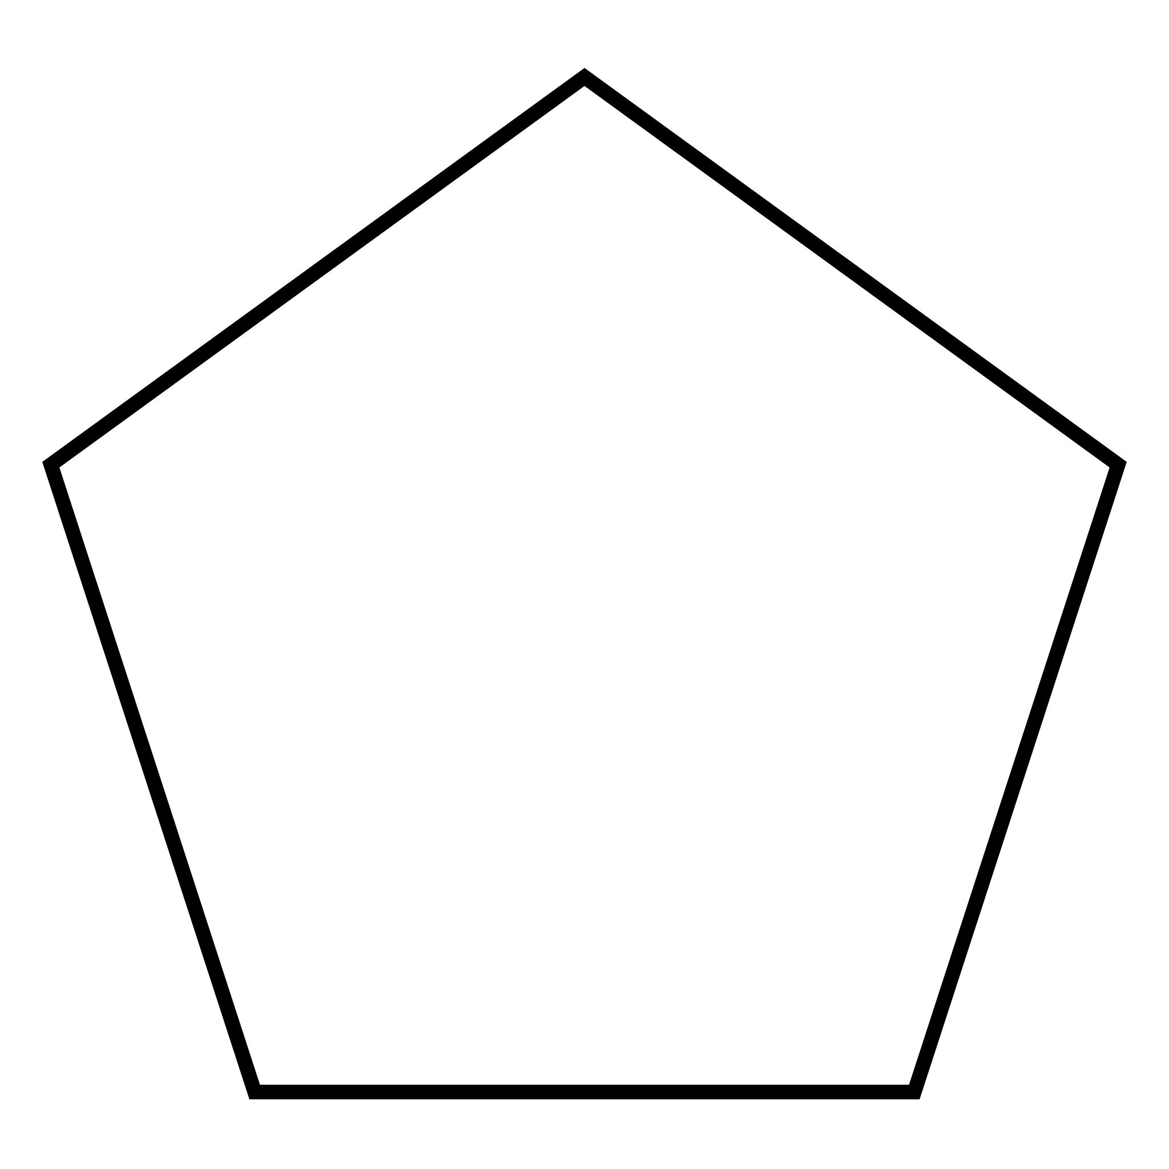

Pentagonal Faces
# Source: AI Source: Provided by: [Data Path: Persons Table -> ID Column: 1, Name_En Column: Motasem Essam] -> From: [ChatGPT] on [7/25/2026]
- Number: 12
- Shape: Regular pentagons.
- Origin: Created by truncating the twelve original vertices.
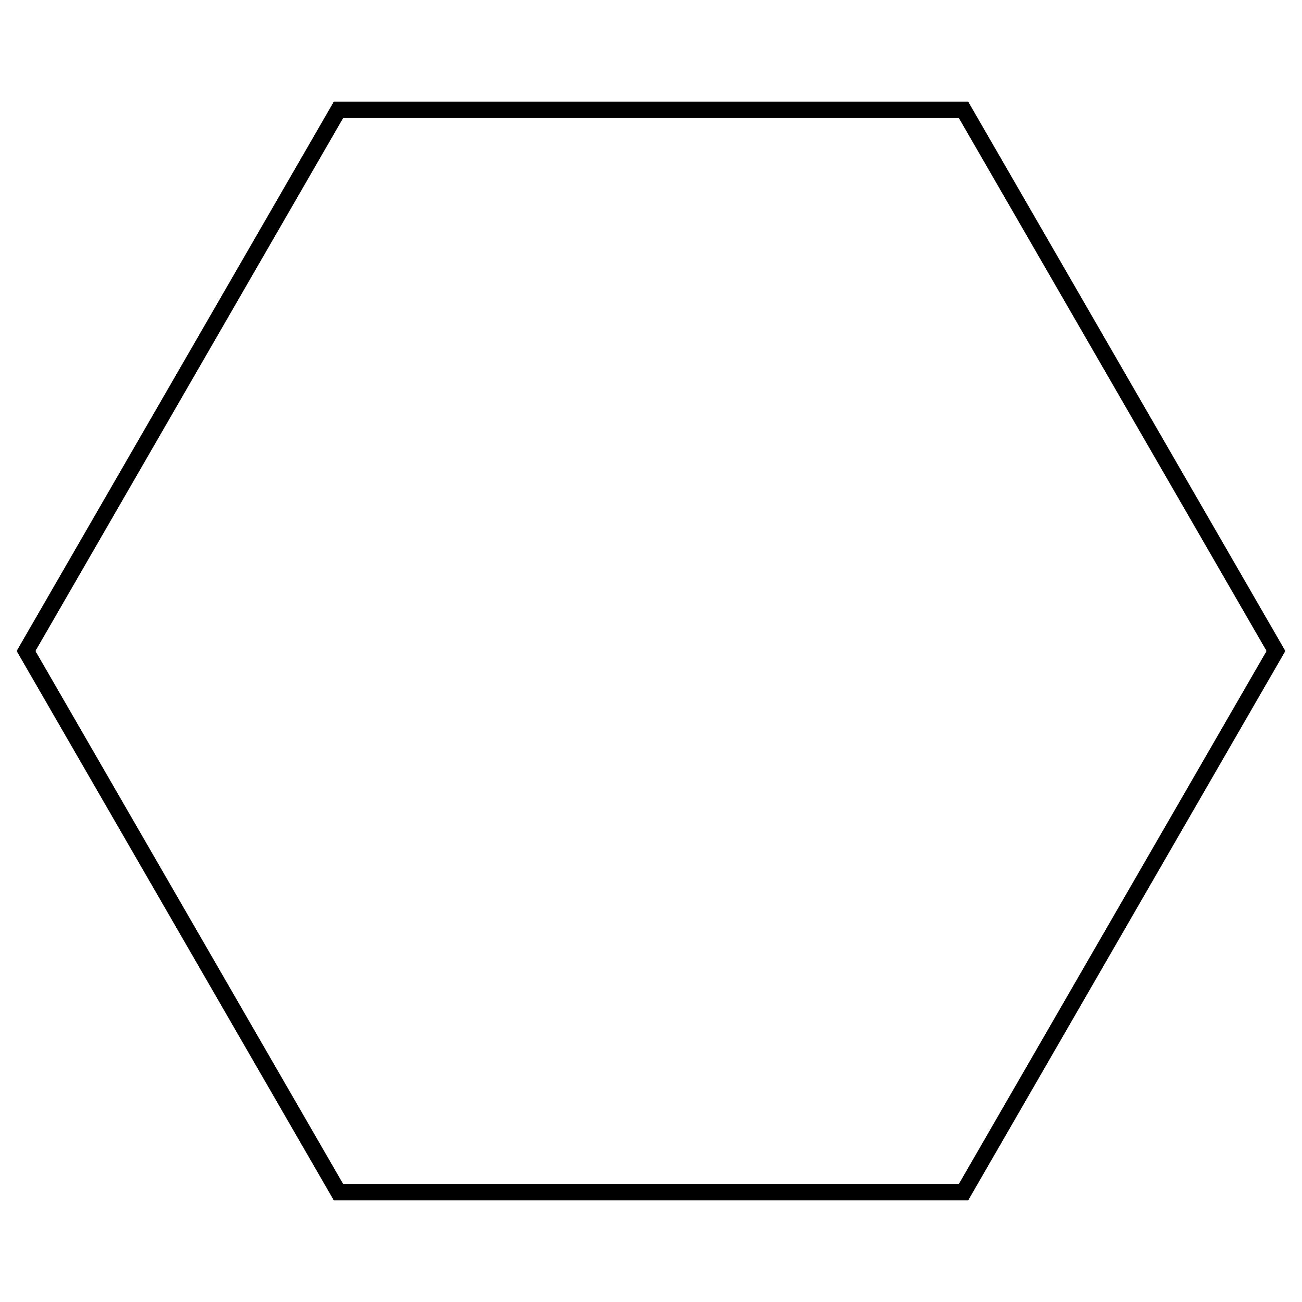

Hexagonal Faces
# Source: AI Source: Provided by: [Data Path: Persons Table -> ID Column: 1, Name_En Column: Motasem Essam] -> From: [ChatGPT] on [7/25/2026]
- Number: 20
- Shape: Regular hexagons.
- Origin: Modified from the twenty original triangular faces.

Mathematical Properties
# Source: AI Source: Provided by: [Data Path: Persons Table -> ID Column: 1, Name_En Column: Motasem Essam] -> From: [ChatGPT] on [7/25/2026]
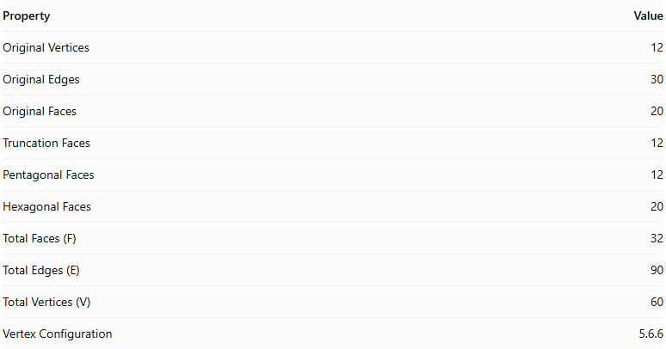
Property | Value
Original Vertices | 12
Original Edges | 30
Original Faces | 20
Truncation Faces | 12
Pentagonal Faces | 12
Hexagonal Faces | 20
Total Faces (F) | 32
Total Edges (E) | 90
Total Vertices (V) | 60
Vertex Configuration | 5.6.6
Euler's Formula:
$$V-E+F=2$$
Substituting:
$$60-90+32=2$$
Therefore, the truncated icosahedron satisfies Euler's formula.

Key Points
# Source: AI Source: Provided by: [Data Path: Persons Table -> ID Column: 1, Name_En Column: Motasem Essam] -> From: [ChatGPT] on [7/25/2026]
- It originates from a regular icosahedron.
- All twelve original vertices are truncated.
- It has 12 regular pentagonal faces and 20 regular hexagonal faces.
- It contains 90 edges and 60 vertices.
- It is an Archimedean solid when uniformly truncated.
- Its faces are regular polygons.
- It is commonly recognized as the geometric structure of a traditional football (soccer ball).

Conclusion
# Source: AI Source: Provided by: [Data Path: Persons Table -> ID Column: 1, Name_En Column: Motasem Essam] -> From: [ChatGPT] on [7/25/2026]
The Truncated Icosahedron is an Archimedean solid formed by uniformly truncating the twelve vertices of a regular icosahedron. It consists of twelve regular pentagonal faces and twenty regular hexagonal faces, with a total of 32 faces, 90 edges, and 60 vertices.

